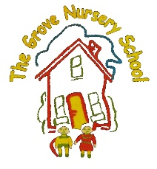 The Grove Nursery School Home/School Links September ‘23 Topic = ‘Nursery Rhymes’
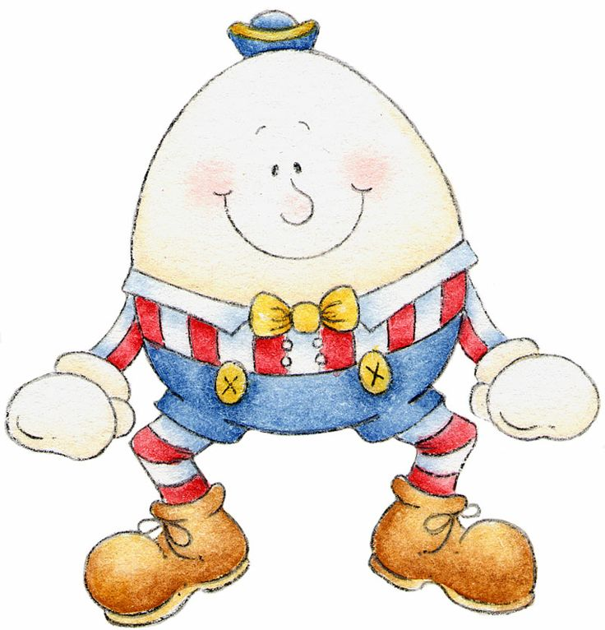
Personal, Social &  Emotional Development-  How we & others feel! | - Remember to tidy up your toys. If you have ‘Alexa’, ask her to play some ‘Tidy Up Music’ please.  - Practise washing your hands. Sing ‘This is the Way We Wash our Hands’ x2. This will help to kill the ‘invisible’ germs.  - Help to set the table for tea. Name utensils and crockery e.g. “cup, knife, fork, spoon, glass, plate, bowl” What do you do when your plate/cup/bowl is empty? Practise using a knife, fork and spoon.
Early Mathematical  Experiences-  Shapes, colours, patterns, counting, numbers | - Lots of Nursery Rhymes /Action Songs contain numbers e.g. 3 Blind Mice, 2 Little Dickey Birds, 5 Little Monkeys, Five Brown Teddies, 12345 Once I Caught a Fish Alive.  - Rote count up to 10. Count everything, e.g. stairs up to bed, buttons on clothes and tins in the shopping bag.  - Use words to describe position. “Jack and Jill, Hickory Dickory Dock, Incy Wincy Spider, Wind the Bobbin Up, Wee Willie Winkie”. Emphasise the positional words in rhymes and songs.
Language & Communication-  Stories, Songs, Rhymes, Mark Making and Literacy | - Read ‘Our Book about Nursery’. Can you remember all the teachers’ names? What do you like to play with in school?  - We have lots of rhymes/ songs on our monthly Song/Rhyme Sheet for you to continue to sing at home. Don’t forget to do the actions too. Check out the school website.  - Borrow books from the school library in the hall. Don’t forget to sign them out in your page in class file and back in again!
Physical Development-  Gross and Fine Motor Skills  Inside and outdoors! | - Practise pouring water from a jug into a cup/bottle (in the bath, washing up in the sink, juice into a cup).  Use language such as “Full, empty, more, enough, overflow, a little, too much”.  - Play ‘Follow The Leader’, clap hands, tap head, shake fingers, stamp feet etc. Take it in turns to follow/lead. Get lots of family members to join in. How many different actions can you think of?  - Do the actions to “If You’re Happy and You Know It”. Make up some silly actions to make you smile and others laugh!
Creative Development-  ,’The Arts’- drawing, painting, acting, role play, dough, junk art, dancing | - Can you find objects that are “the same” colour? Put them into groups. See how many different groups you can make. What is your favourite colour?  - Use a cardboard ‘egg’ or circle shape as Humpty Dumpty and use broken egg shells to give him a ‘cracked’ face or draw a face on a hard-boiled egg. Would Humpty be happy or sad? Why do you think that?
The World Around Us-  Nature, Seasons, Science & Technology, The Past, Animals, Other lands | - Take a walk outdoors and listen carefully. What different sounds can you hear? Some are “loud”, others “quiet”.  - Listen to sounds indoors. Watch “Peace At Last” a story by Jill Murphy on YouTube.  - What is your favourite animal? Can you make the noise it makes? Does it live in your house, in the jungle/zoo, in the countryside, in the sea, on a farm? Is it big, small, cuddly, scary?

