THE GROVE NURSERY SCHOOL

‘Minibeast’ Rhymes & Songs

LITTLE ARABELLA MILLER

Little Arabella Miller found a woolly caterpillar.

C:\Users\Ivan\AppData\Local\Microsoft\Windows\Temporary Internet Files\Content.IE5\WPLR2FTE\MC900434575[1].wmf

First it crawled upon her mother,

Then upon her baby brother.

Both said “Arabella Miller,

Take away that caterpillar!”

THERE’S A TINY CATERPILLAR ON A LEAF Tune = She’ll be coming round the Mountain.

There’s a tiny caterpillar on a leaf (wiggle, wiggle)

C:\Users\Ivan\AppData\Local\Microsoft\Windows\Temporary Internet Files\Content.IE5\XFJ1TQET\MC900197570[1].wmf

There’s a tiny caterpillar on a leaf (wiggle, wiggle)

There’s a tiny caterpillar, tiny caterpillar,

There’s a tiny caterpillar on a leaf. (wiggle, wiggle)

He will eat the leaves around him ‘til he’s full.(Yum yum).........

A cocoon is what he’s spinning for his home, (spin spin)........

Then he’ll be a butterfly and fly away. (flap, flap)........



TWO LITTLE BUTTERFLIES

Two little butterflies sitting on a leaf.

One called Bethany, one called Keith.

Fly away Bethany, fly away Keith.

Come back Bethany. Come back Keith. (Kiss, kiss)

ONE ELEPHANT WENT OUT TO PLAY (SONG)

C:\Users\Ivan\AppData\Local\Microsoft\Windows\Temporary Internet Files\Content.IE5\73V8A5BR\MC900364598[1].wmfC:\Users\Ivan\AppData\Local\Microsoft\Windows\Temporary Internet Files\Content.IE5\MPG4034X\MC900034160[1].wmf

One elephant went out to play,

On a spider’s web one day.

He had such enormous fun,

He asked another elephant to come.

Two elephants went out to play.....

SPIDER POEMS

C:\Users\Ivan\AppData\Local\Microsoft\Windows\Temporary Internet Files\Content.IE5\UMZV0ZSJ\MC900390916[1].wmf

I have a little spider.

I’m very fond of him.

He climbs on to my shoulder

And then on to my chin.

He crawls down my arm

And jumps on to my leg.

Now he’s a tired little spider,

So I’ll put him into bed!

Little Miss Muffet

Sat on her tuffet,

Eating her curds and whey.

Along came a spider

And sat down beside her.

And frightened Miss Muffet away!

C:\Users\Ivan\AppData\Local\Microsoft\Windows\Temporary Internet Files\Content.IE5\KZMFVIVN\MC900090999[1].wmfTHERE’S AWORM AT THE BOTTOM OF THE GARDEN. (song)

There’s a worm at the bottom of the garden,

And his name is Wiggly Woo.

There’s a worm at the bottom of the garden,

And all that he can do, is

Wiggle all night and wiggle all day.

C:\Users\Ivan\AppData\Local\Microsoft\Windows\Temporary Internet Files\Content.IE5\KZMFVIVN\MC900090999[1].wmf

The people round here, they all do say,

“There’s a worm at the bottom of the garden,

And his name is Wiggly,

Wig, Wig, Wiggly,

Wig, Wig, Wiggly, Woo.”

C:\Users\Ivan\AppData\Local\Microsoft\Windows\Temporary Internet Files\Content.IE5\N32Q5PDU\MC900140517[1].wmf

Her

APPLE SURPRISE

Way up high in the apple tree

A little brown worm smiled at me.

I winked my eye and what do you suppose?

A shiny red apple dropped on my nose!

C:\Users\Ivan\AppData\Local\Microsoft\Windows\Temporary Internet Files\Content.IE5\KZMFVIVN\MC900215112[1].wmf

HERE IS THE BEEHIVE

Here is the beehive

But where are the bees?

Hidden away, where nobody sees.

C:\Users\Ivan\AppData\Local\Microsoft\Windows\Temporary Internet Files\Content.IE5\KZMFVIVN\MC900151207[1].wmfC:\Users\Ivan\AppData\Local\Microsoft\Windows\Temporary Internet Files\Content.IE5\KZMFVIVN\MC900151207[1].wmfC:\Users\Ivan\AppData\Local\Microsoft\Windows\Temporary Internet Files\Content.IE5\KZMFVIVN\MC900151207[1].wmfC:\Users\Ivan\AppData\Local\Microsoft\Windows\Temporary Internet Files\Content.IE5\KZMFVIVN\MC900151207[1].wmfC:\Users\Ivan\AppData\Local\Microsoft\Windows\Temporary Internet Files\Content.IE5\KZMFVIVN\MC900151207[1].wmf

Watch and you’ll see them

Come out of their hive.

One, two, three, four, five.

BUZZZZZZZZZZ.

BIG BUGS, SMALL BUGS Tune = Frere Jacques

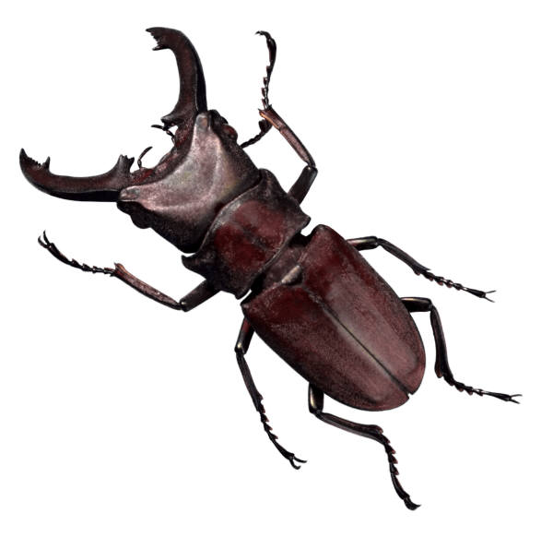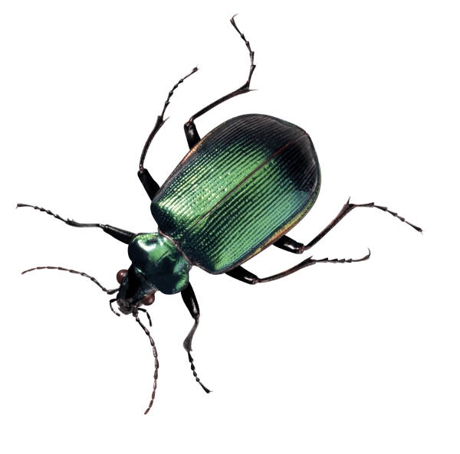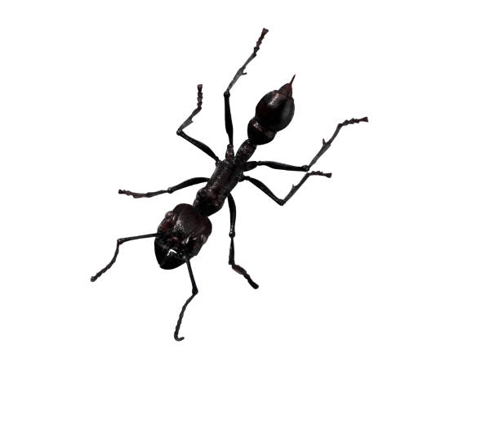

Big bugs, small bugs.

Big bugs, small bugs.

See them crawl on the wall.

Creepy, creepy, crawling.

Never, never, falling.

Bugs, bugs, bugs.

Bugs, bugs, bugs.

I’M A LITTLE BUTTERFLY Tune = I’m a little teapot



I’m a little butterfly

And I have wings.

I fly around and I see all things.

When I see a flower that looks just great.

I call out loud to all my mates !

CATERPILLAR LEGS

C:\Users\Ivan\AppData\Local\Microsoft\Windows\Temporary Internet Files\Content.IE5\KZMFVIVN\MC900232408[1].wmf

Little boys have two legs.

Little dogs have four.

But the furry caterpillar

Has more and more and more !

5 LITTLE DRAGONFLIES

C:\Users\Ivan\AppData\Local\Microsoft\Windows\Temporary Internet Files\Content.IE5\73V8A5BR\MC900391416[1].wmf

1 little dragonfly with four shiny wings,

2 little dragonflies learning how to sing,

3 little dragonflies zipping up and down,

4 little dragonflies resting on the ground,

5 little dragonflies going home for lunch,

Along came a frog and Munch, Munch, Munch !

LADYBIRD RHYMES

C:\Users\Ivan\AppData\Local\Microsoft\Windows\Temporary Internet Files\Content.IE5\MPG4034X\MC900002030[1].wmf

Ladybird, ladybird, fly away home.

I saw a ladybird fly through the air

But when I tried to catch her

She wasn’t there.

She was so pretty, red and black.

Your house is on fire

And your children have gone.

All except one and that’s little Ann.

She crept under a frying pan.

I waved goodbye as she flew back.

SLOWLY SLOWLY (finger rhyme)

Slowly, slowly, very slowly, (walk fingers up arm)

C:\Users\Ivan\AppData\Local\Microsoft\Windows\Temporary Internet Files\Content.IE5\NT3IN3FD\MC900391446[1].wmf

Creeps the garden snail.

Slowly, slowly, very slowly,

C:\Users\Ivan\AppData\Local\Microsoft\Windows\Temporary Internet Files\Content.IE5\XFJ1TQET\MC900445090[1].wmf

Up the garden rail.

Quickly, quickly, very quickly, (run fingers up arm)

Runs the little mouse.

Quickly, quickly, very quickly,

Round about the house.